Name: Waleed saeed sayed salem

B.N:

Date:

Topic: Mobile computing

Application Brief: mobile computing is among the most important inventions that a person has come up with. It saved a lot of time and effort and with the tremendous development that took place in the world, it had the largest share of this development, but nevertheless it is a double_ edged sword and it was necessary to show the side that was invented for it and review how rapidly it has evolved, so the mobile computing has been chosen.

Screenshots:

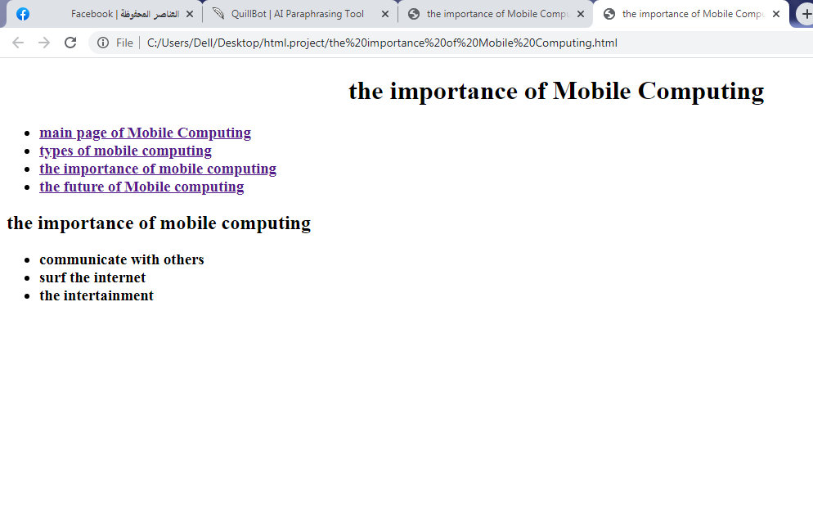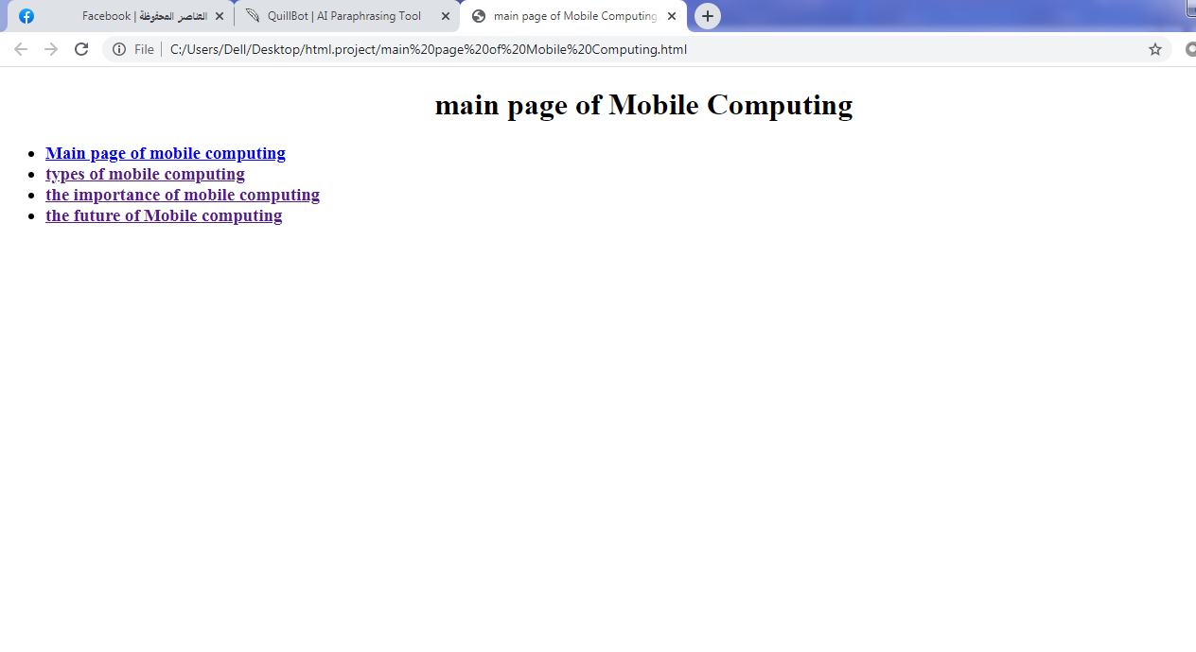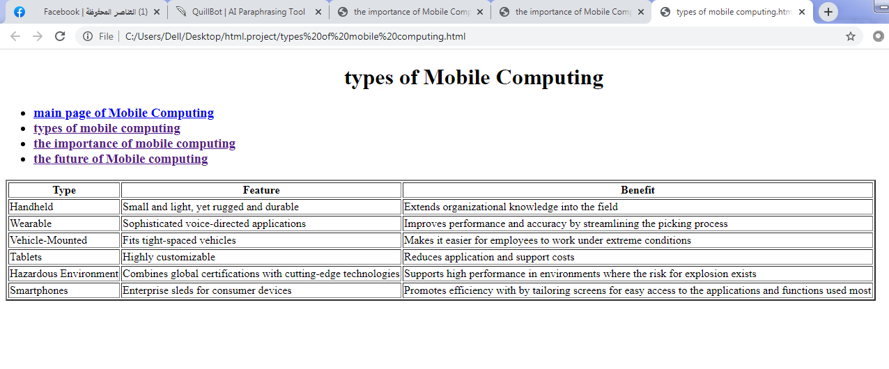

Source code:

